Therapist ____________________________ Date: _______________________________

Client Intake Form
Name: |  |  | Home Phone:
Street Address: |  |  | Work Phone:
City, State Zip: |  |  | Cell Phone:
Email:
Date of Birth: |  |  | Your Occupation:
Emergency Contact: |  |  | Phone:
Referred by: (Name of Referee, Flyer, Ad etc.):
Health / Medical History
Are you seeing a health care professional? |  | Comment:
Date of last visit or checkup:
Are you taking any prescribed medications? |  | Comment:
Are you taking any supplements, herbs, over the counter medications, or known blood thinners? |  | Comment:
Do you have any known allergies? |  | Comment:
Do you have any prosthetics? (Contacts, hearing aids etc.) |  | Comment:
New Conditions (Are you experiencing, or do you have any of the following): Circle all that apply
Cold / Flu | Burns / Sunburn |  |  | Headaches
Fever | Numbness / Tingling |  |  | Arthritis / Tendonitis
Infections | Skin Conditions / Warts |  |  | Cuts / Bruises
Contagious Conditions | Digestive Disorders |  |  | Depression / Anxiety
Possible Pregnancy | New Tattoos / Piercings |  |  | Muscular / Skeletal Disorders
Sprains / Strains | Injection Sites |  |  | Scars
Have you ever been diagnosed with, or been advised to seek treatment for: Circle all that apply
High / Low Blood Pressure | Varicose Veins |  |  | Osteoporosis
Stroke | Bruising Easily |  |  | Disc Disorders
Diabetes / Low Blood Sugar | Lymphatic Conditions |  |  | Nerve Disorders
Heart Disease | Kidney / Bladder Conditions |  |  | Seizure Disorders
Aneurysm | Cancer |  |  | Chronic Respiratory Conditions
Phlebitis / Blood Clots | Liver / Gall Bladder Conditions |  |  | Asthma
Anemias /Blood Disorders | Reproductive System Conditions |  |  | Chronic Sinus Conditions
Any other conditions not mentioned above?
Do you typically like a quiet or conversational massage session?

Have you ever had any:
Hospitalizations and/or Surgeries
Accidents and/or Injuries
Broken and/or Dislocated Bones
If Yes, Please Explain (Include Dates):

Massage History
Have you received therapeutic massage before? If Yes, date of last massage:
Frequency:
Likes and/or Dislikes:

Why did you choose Massage Therapy?

What do you think is the general condition of your health?

What hobbies, activities or recreation do you participate in?

On the following image, please mark any areas that may be of relevance to this massage session.

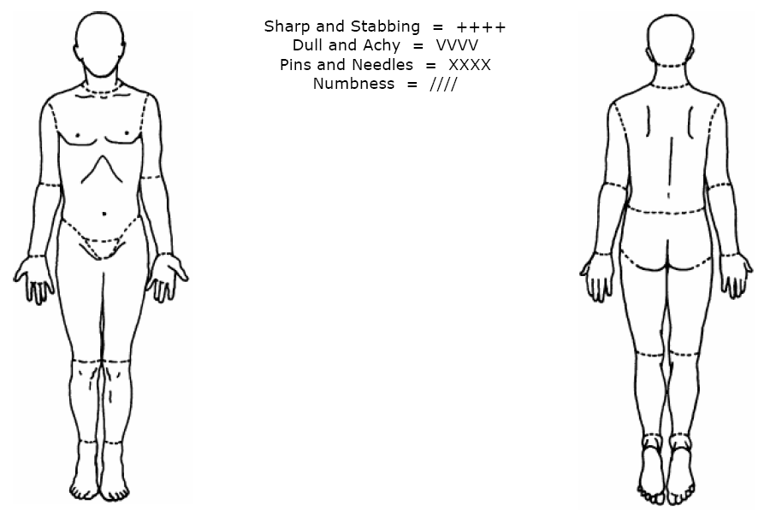

Please Read, Sign and Initial Below:

Massage is provided for the basic purpose of relaxation, stress reduction and relief of muscular tension. Massage services (and possibly information exchange) is designed to be a health aid and is in no way meant to take the place of a physician's care.

Because massage should not be performed under certain medical conditions, I affirm that I have stated all my known medical conditions and answered all questions honestly and I understand that it is my responsibility to keep the massage therapist updated as to any changes in my medical profile.

I also understand that any illicit or sexually suggestive remarks or advances made by me will result in immediate termination of the session with full charge for that session.

Payment is due when services are rendered unless other arrangements have been made prior to my appointment (Gift Certificates, Paid in full memberships & autopay “benefits”).

Signature: ________________________________ Date: _______________________

Appointment Cancellation Policy

Life happens: If you need to miss your hour of BlissBlissBliss, please call or e-mail us (304-413-0270, staff@theblissblissbliss.com) as soon as you know that you will miss your scheduled appointment. Your consideration allows us to manage our schedules.

We encourage a 24 hour notice if you cannot keep an appointment.

Initial Each:

(_____) $0 is charged if you call to cancel 24 hours in advance of your appointment.

(_____) The full charge for the scheduled service will be charged if you do not call and you do not show up for your appointment.

Membership Agreement

Membership allows for discounted prices on “Basic” and “Upgraded” Services. “Basic” treatments are: Swedish, Pregnancy Massage, Thai Yoga Massage, 1 hour private yoga & basic Reiki.
When paying in full, clients accrue the number of “Basic” benefits associated with the plan they have chosen. When on the monthly payment plan, each monthly payment accrue ONE “benefit” for a basic treatment. Clients may choose upgraded services and apply the cost of the accrued benefit to that service and pay the difference.

This agreement is between: _____________________________(Client Name) and

BlissBlissBliss for 1 year _________ (Start Date)_________(End Date).

As a member of BlissBlissBliss, I agree to: Initial: (_____) A $10 annual membership fee.

I also agree to (Initial One): (_____) Agree to purchase the BlissBlissBliss Body Work Treatments Package for $342 ________ (6 “Basic” visits paid in full).

OR (_____) Agree to an automatic monthly charge of $57 (6X) to my credit/debit card on the first day of each month for 6 months. Each month successfully charged allows me to accrue a “Basic” service benefit that I may use within 12 months of start of payment.

Initial Each:

(_____) I understand that my membership is for me to use and not to be shared with anyone else.

(_____) I understand that my membership will be deactivated if payment is more than 30 calendar days late.

(_____) I understand that my credit/bank card is stored on a secure server.

(_____) I understand that a sur charge of $10 each “expired beneefit” could be added to my bill if I do not use my 6 visits within the year of membership.

(_____) I understand that my credit/bank card is stored on a secure server.

Membership Cancellation Policy

(_____) Notification to cancel is allowed at any time during the contract period with a $90 cancellation fee. All Accrued benefits will be converted to gift certificates for the client to use or share with friends/family. No refunds are offered. Gift certificates are to be used at dollar value and applied to any guest priced service.

